


Itinerary
Please join the Hubbs-SeaWorld Research Institute supporters, trustees, scientists and community leaders for a very special event, our third annual Bill Poole Memorial Angling Tournament.

Angling Seminar and Captain’s Meeting
Thursday, July 28, 2011, 7:00 to 9:00 p.m.
Pick up angler goody bags. Find out where the fish are and how the experts catch them. Learn about bait availability, fishing conditions, special awards, final rules and times, and other last-minute information.

Angling Tournament
Lines In: 6:00 p.m. Friday, July 29 ~ Lines Out: 6:00 p.m. Saturday, July 30, 2011
Fish for a variety of species such as halibut, tuna (albacore, bluefin, or yellowfin), yellowtail, and white seabass. No tournament boundaries apply. (Lines In/Lines Out times tbd.) This is a family-oriented, non-money tournament designed to encourage sportsmanship and ocean awareness and conservation.

Awards Barbecue
Sunday, July 31, 2010, 11 a.m. to 2:00 p.m.
Enjoy a gorgeous bayside setting while dining on delicious cultured fish tacos prepared on-site by local chefs. Visit with SeaWorld’s animal ambassadors. Bid on terrific silent auction items. Tour the Institute’s hatchery operations and more.

2011 Honorees

Don Hansen ~ The Bill Poole Memorial Award . This award is given to someone who has dedicated a lifetime commitment to the outdoor sporting life.

Jock Albright ~ The Milt Shedd Memorial Award. This award is given to someone who has made a significant contribution to the white seabass replenishment program.

Beneficiary
Proceeds benefit the Hubbs-SeaWorld Research Institute’s white seabass replenishment program.

HSWRI is a leading independent, non-profit marine research institute and has been around for nearly 50 years. They are the source for white seabass fingerlings for all the grow-out pens up and down the coast. Since 1983 they have added nearly 1.8 million juvenile white seabass to the fishery, and all of us have enjoyed the results over the past few years. Their work in other areas of marine science is equally impressive.

Chartered "to return to the sea some measure of the benefits derived from it," the Institute conducts innovative scientific research throughout the world to conserve our living marine resources, our ocean-based economy and our quality of life.

Involvement

You can participate in the Third Annual Bill Poole Memorial Angling Tournament by becoming an event sponsor (see reverse Sponsorship Opportunities for details). To learn more about how you can get involved please contact Karen Terra at 619-226-3881.
HSWRI
2595 Ingraham Street
San Diego, CA 92109
www.hswri.org

Sponsorship and Raffle/Auction Donor Response Form

- Yes, I would love to support the Bill Poole Memorial Angling Tournament by:

❑ becoming the White Seabass Presenting Sponsor for $10,000

❑ becoming a Yellowtail Sponsor for $5,000

- becoming a Halibut Sponsor for $2,5000

- becoming a Cabezon Sponsor for $1,000

- becoming a Vermillion Sponsor for $500

- donating the following prize(s) (include value)

- I am unable to participate in the tournament but would like to attend the Awards Barbecue on
Sunday, July 31. Number of guests attending will be _____ at $25 per person for a total of $

- I cannot attend but would like to buy ____ raffle tickets at $5 each for a total of $

- I would like a little more information. Please have someone call me at

❑ I cannot participate but would like to make a 100% tax-deductible contribution of $

For all printed materials, please list my name as

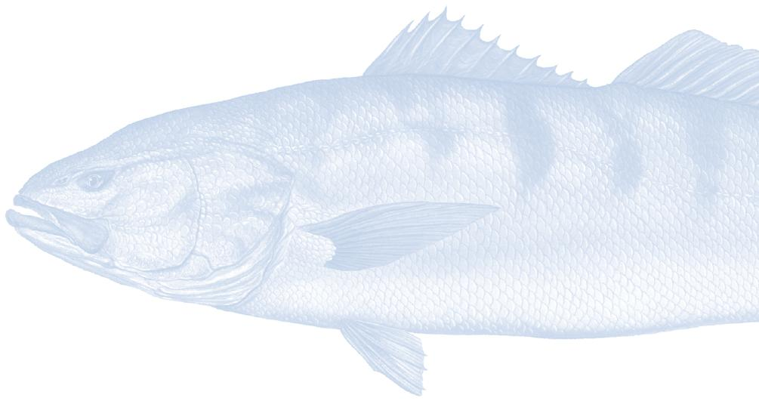
Name

Title Company

Address

City/State/Zip

Phone/Fax E-mail

PAYMENT INFORMATION

❑ Enclosed is a check payable to HSWRI, Tax ID: 95-2304740
❑ Please charge $ to  Amex  MasterCard  Visa

Card Number Exp Date

Name on Card

Signature

To receive recognition on the program booklet, please respond before May 15, 2011
Please return this form in the enclosed reply envelope or mail to:

HSWRI, 2595 Ingraham Street, San Diego, CA 92109 or Fax to 619-226-3944.
To access this form electronically go to www.hswri.org.

If you have questions or would like more information, please call 619-226-3881.

